GOVERNMENT DEGREE COLLEGE, YELESWARAM
(Affiliated to Adikavi Nannaya University)
KAKINADA District.

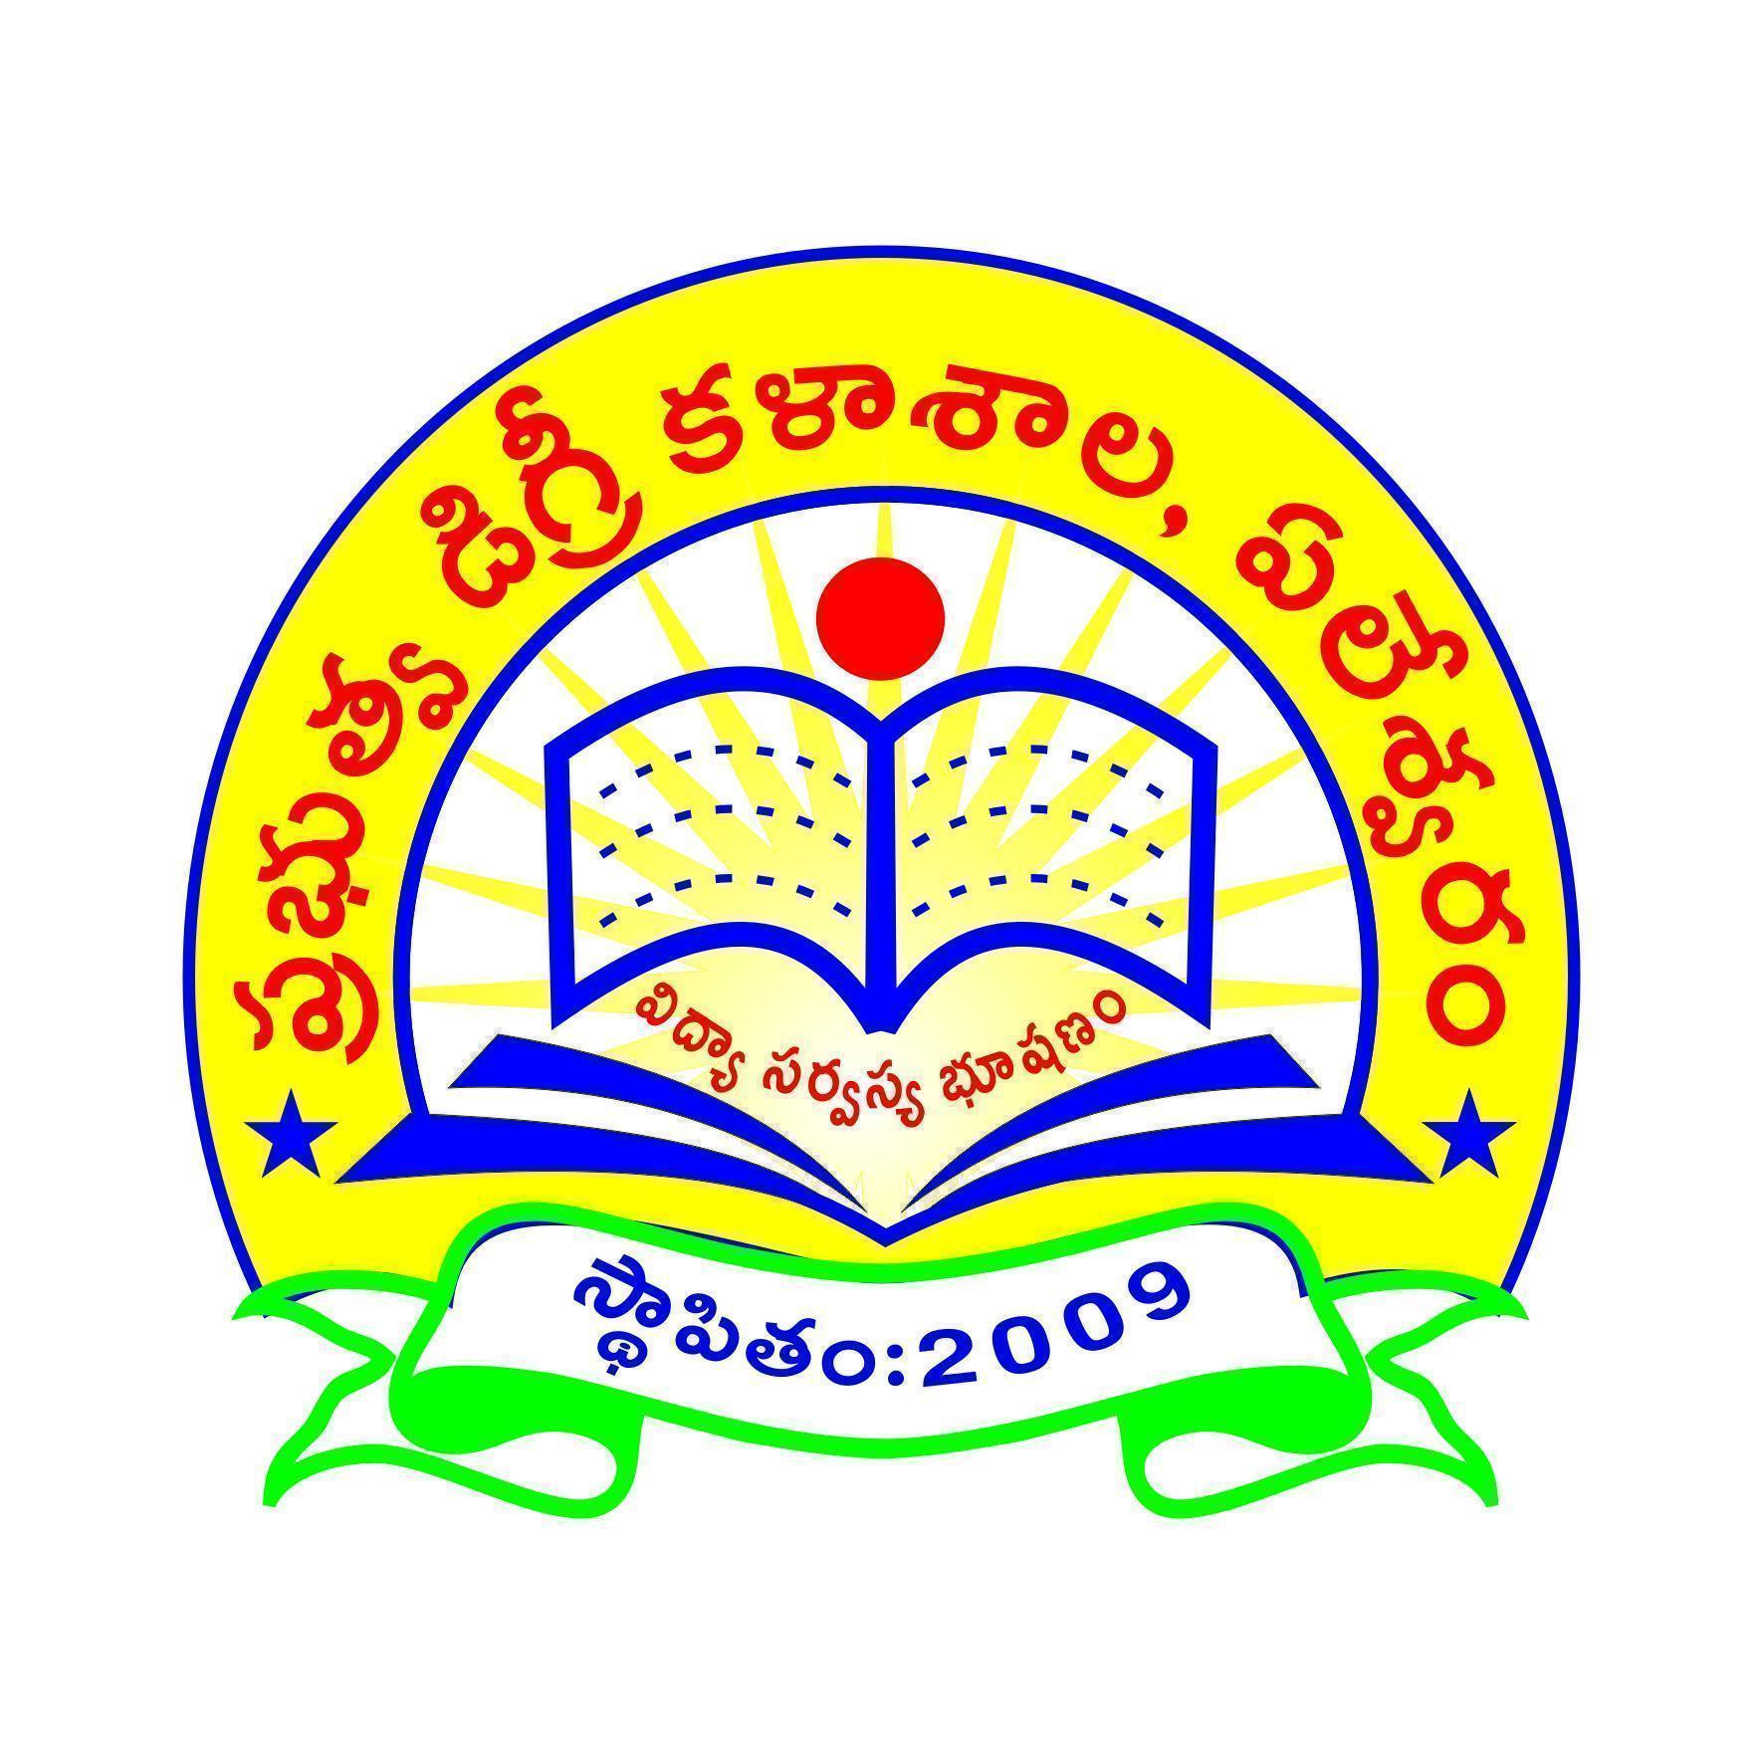
2024-25

NAME OF THE ACTIVITY: WORLD TRIBAL DAY

DATE: 09-08-2024

ORGANISED BY: Staff & students
GOVERNMENT DEGREE COLLEGE, YELESWARAM KAKINADA district
ACTIVITY REGISTER 2024-2025
DATE | 09-08-2024
Title of the Activity | WORLD TRIBAL DAY
Conducted through (National/State/Zonal/NRC/District/Regional/College etc., | College level
Name of the Organizing Department/Committee | Cultural Club
Details of Resource Persons(Name, Designation etc.) | Principal
No.of Students Participated | 64
Objectives of the activity | - To recognise and celebrate the contributions and cultures of indigenous peoples around the world.  - This day also serves as a platform to address the challenges faced by these communities and advocate for their rights and preservation
Brief Report on the activity:
- World Tribal day or Aadivasi Diwas was celebrated at Govt. Degree College, Yeleswaram on 9 August 2024.
- Principal, Dr. D. Suneetha addressed the students and staff.
- She sermonized the significance of the Aadivasi Diwas.
- She acknowledged the contributions of indigenous people and their contributions to the nation. She also emphasized the necessity of preserving their culture.
- The NSS Coordinator, Dr. Prayaga Murty Pragada orated the uniqueness of the various tribal cultures.
- Sri.VVS Prasad, Lecturer in Political Science and Ms. J Mary Roselina, Lecturer in History also shared their views on World Tribal day.
- A student from III B.Sc., recited about her own tribe and culture.
- Students from II B.Sc., sang a tribal song which narrates the significance of indigenous people.
- An essay writing competition was conducted on the topic “ Tribal Cultures in India”
- Prizes were distributed to the winners.
Outcome of the activity:
- Raising awareness on
- Protecting rights: The day aims to protect the rights of indigenous communities, including their fundamental rights, freedoms, and voices.
- Honoring cultures: The day aims to honor the diverse cultures, languages, and customs of indigenous peoples.
- Promoting unity: The day aims to cultivate unity among indigenous communities.
- Acknowledging contributions: The day aims to acknowledge the contributions of indigenous communities.
- Discussing preservation: The day provides an opportunity to discuss how to preserve indigenous languages, customs, and practices.
- Promoting policies: The day provides an opportunity to promote policies that protect the rights of indigenous peoples.
Signatures of the organizing committee:  - 1.Dr.D.Chenna Rao  - Sri.K.Venkateswara Rao  - Dr.P.Prayaga Murty  - Sri.K.Suresh  - Sri.V.Rama Rao  - Smt.K.Srilakshmi  - Dr.Madina Saheb SK  - Sri.VVV Siva Prasad  - Sri.B.Veerabhadra Rao | 10. Sri.K.Bangarraju  11. Kum.J.Mary Rosalina  12. Smt.CH.Pushpa  13. Sri.P.Satish Prasad  14.Sri.P.Satyanarayana  15.Sri.E.Dharma Raju  16.Smt.A.Divya  17.Smt.D.Ramalakshmi  18.Smt.K.Kamala  19.Smt.K.Kalavathi
Signature of the IQAC Coordinator | 
Signature of the Principal | 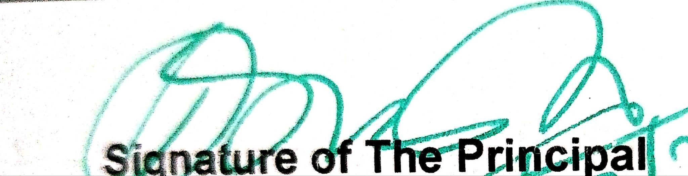

Supporting Documents:
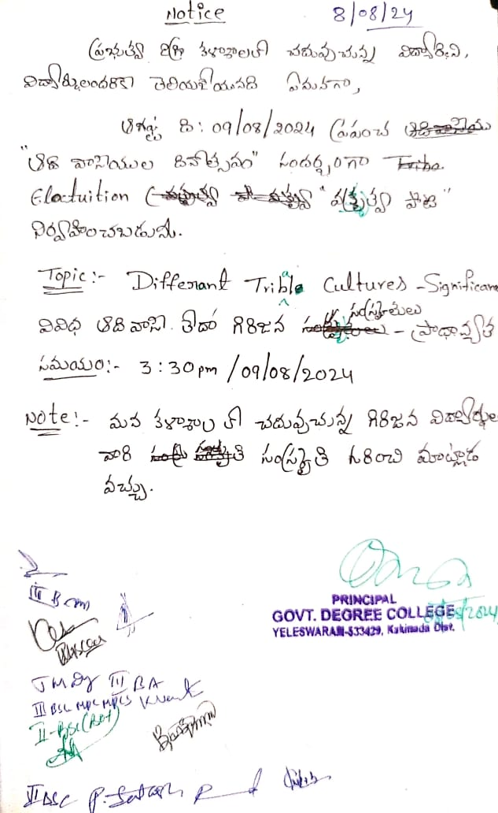

Photo Gallery
